EDM 1 TEACHER: ESPERIDION S. ABELLANA **RETURN THIS COPY TO ME AT THE END OF THE CLASS**

Instructions: In groups of 5-6 members, make a PPT or an infographic or a diagram on the 3 saints’ (San Carlos Borromeo, St. Arnold Janssen, and St. Joseph Freinademetz) acts of witnessing to the Word (Jesus Christ). Present in the classroom in 10-15 minutes. Kindly give me a copy of your group work.

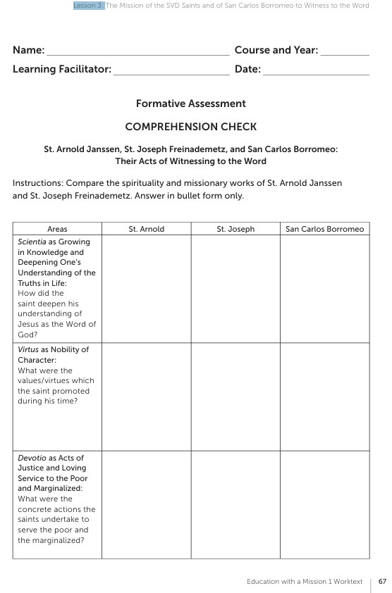

Criteria for Grading: 1) content 18 pts., 2) Presentation/Creativity/Preparation 12 pts., 3) Ability to answer questions/Teamwork 1